8a: Class Diagram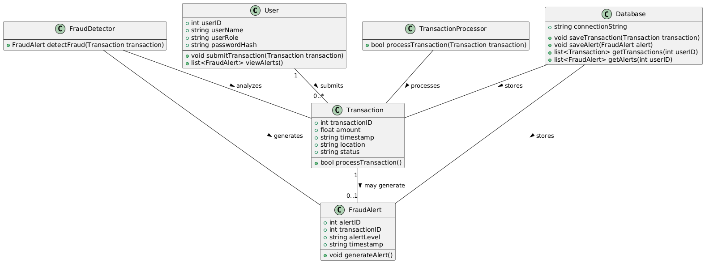

8b: Data Types and Operation Signatures

For each class, we define the data types of all attributes and the signatures of operations.

1. **User Class**:
   * **Attributes**:
     + userID: int
     + userName: string
     + userRole: string
     + passwordHash: string
   * **Operations**:
     + submitTransaction(transaction: Transaction): void
     + viewAlerts(): list<FraudAlert>
2. **Transaction Class**:
   * **Attributes**:
     + transactionID: int
     + amount: float
     + timestamp: string
     + location: string
     + status: string
   * **Operations**:
     + processTransaction(): bool
3. **FraudAlert Class**:
   * **Attributes**:
     + alertID: int
     + transactionID: int
     + alertLevel: string
     + timestamp: string
   * **Operations**:
     + generateAlert(): void
4. **TransactionProcessor Class**:
   * **Operations**:
     + processTransaction(transaction: Transaction): bool
5. **FraudDetector Class**:
   * **Operations**:
     + detectFraud(transaction: Transaction): FraudAlert
6. **Database Class**:
   * **Attributes**:
     + connectionString: string
   * **Operations**:
     + saveTransaction(transaction: Transaction): void
     + saveAlert(alert: FraudAlert): void
     + getTransactions(userID: int): list<Transaction>
     + getAlerts(userID: int): list<FraudAlert>

8c: Traceability Matrix

The **Traceability Matrix** outlines how each class evolved from the domain concepts identified in the earlier stages of the project. Here, we map domain concepts to the corresponding classes in the system:

| **Domain Concept** | **Class** | **Rationale** |
| --- | --- | --- |
| User | User | Represents individuals interacting with the system |
| Transaction | Transaction | Each transaction corresponds to a financial operation |
| Fraud Alert | FraudAlert | Alerts generated when suspicious activity is detected |
| Transaction Processor | TransactionProcessor | Handles the processing of transactions |
| Fraud Detection | FraudDetector | Analyzes transactions for suspicious patterns |
| Data Storage | Database | Manages persistent storage of user, transaction, and alert data |
|  |  |  |

Explanation:

* The **User** class directly evolved from the domain concept of "User" who submits transactions.
* The **Transaction** class evolved from the concept of financial transactions submitted by the users.
* The **FraudAlert** class corresponds to the fraud detection concept, which was originally derived from the need to alert suspicious transactions.
* **TransactionProcessor** and **FraudDetector** emerged from the need to separate processing and detection responsibilities, adhering to the **Single Responsibility Principle**.
* **Database** was introduced to handle persistent storage, evolving from the need to store data long-term.

This matrix shows the traceability from domain concepts to class structure, ensuring that all requirements are met effectively through the system's design.